Vivek Patil’s
Weekly Market Analysis
03-Sep-2018

Index opens gap-up on ‘Mon again, holds it till ‘Friday

Bulls to maintain control if gap-up/Grey channel hold

Last Close : Sensex 38645 (Nifty Spot 11681)
Trade for the Week
Positive if Sensex holds above 38562 (Nifty 11640)
[Upside targets/resistances at 38838(11727)/38989(11760) or higher]
Negative if Sensex keeps below 38838 (Nifty 11727)
[Downside targets/supports at 38562(11640)/38417(11596) or lower]

[Technical readings carried forward from previous weeks are shown in italics.
Readers can easily identify the new arguments which are written in regular font]

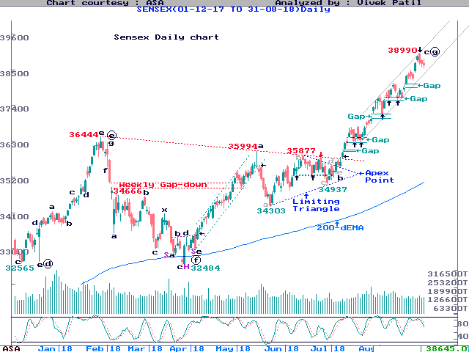
Last week we discussed, “With Nifty PE Ratio near historic highs, we had listed our maturity signs. However, none of the -ve signs has unfolded as yet … until the maturity signs actually unfold, continue with a selectively +ve approach in the market … PE Ratio of NSE500 Index still has upside potential of its all-time high achieved during ‘2000 … On Sensex, the action comprising the 3 Bear candles looks more like a ‘pause’ rather than a ‘fall’ … Bulls can maintain control if pause remains restricted to just 2-3 days … ”
Restricting the pause to exactly 3 Bear candles, Sensex opened with a gap-up action on Monday, and was up 738 pts by Wednesday morning. However, with Engulfing Line Bear candle on that day, it reversed, and came down 428 pts by Friday. Despite the loss, it finally managed to settle 393 pts or 1% higher, forming the 6th consecutive Bull candle on its Weekly chart. The Power/Metal/IT/Pharma Indexes gained 3-5% each. The late pressure came from Reliance and Yes Bank.
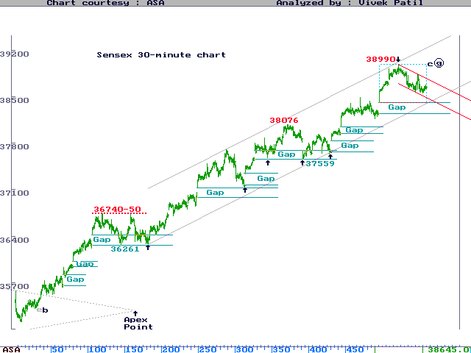

Last week’s hesitation came exactly from upper end of the Grey channel shown on the Daily as well as Weekly chart. These channels enclose “higher top higher bottom” formation inside the c-leg of larger “g”.
As we showed on the chart below, the rallying segment of Jul-Aug’18 (c-leg) looks similar to the rallying segment of Apr-May’18 (a-leg). Both the rallies were channeled well, shown enclosed inside the Dark Blue color parallel lines.
The magnitude of Apr-May’18 rally was about 3500 Sensex pts in 34 (Fibonacci Number) days. The magnitude of the current Jul-Aug rally is similar, about 3600 Sensex pts in 38 days, at least so far.
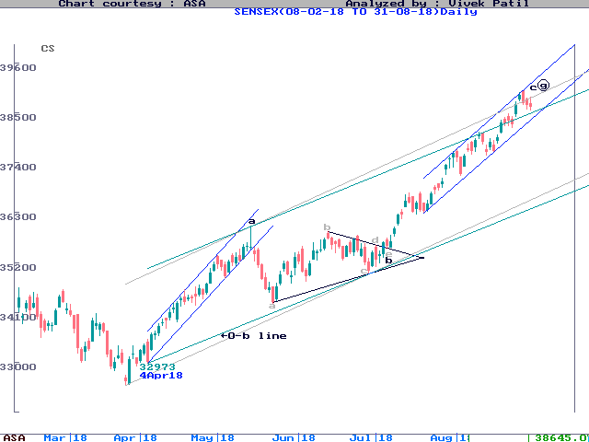
This similarity makes Sensex test upper end of the larger Grey channel as shown on the chart above. Having achieved upper end of the larger channel, we can raise a question if the current rally would now mature.

Last week, Nifty PE Ratio achieved its all-time high of 28.72, slightly above its ‘2000 high of 28.47 and ‘2008 high of 28.29. Since market showed major corrections from such high PE levels in the past, we could raise a warning flag on this parameter as well.
However, we looked at the PE Ratio for NSE500, as per the following chart, which showed upward potential to test its ‘2000 levels of 37.26. The NSE500 PE Ratio is currently at 34.50. This chart, remember, is based on the official figures published by the NSE.
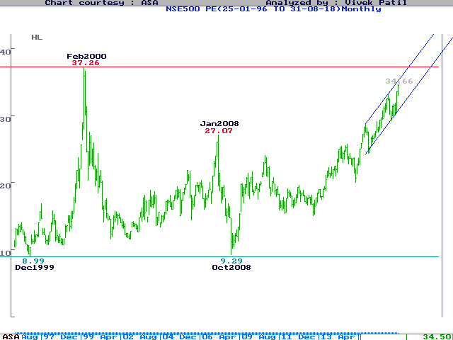
The PE Ratio chart of NSE500 shows higher top higher bottom formation well enclosed inside the Blue rising channel, and its up-trend could continue as long the channel holds intact.
We turned +ve selectively on the broader market since Jun-Jul’18 because the NSE500 Index was testing lower end of its 2-year channel.

During Jun-Jul’18, remember, many stocks from small-Cap and mid-cap categories were testing their lowest levels of ‘2018, and had therefore, turned technically “oversold”.
Last week, the NSE500 Index made a new all-time high, justifying our selectively +ve approach.
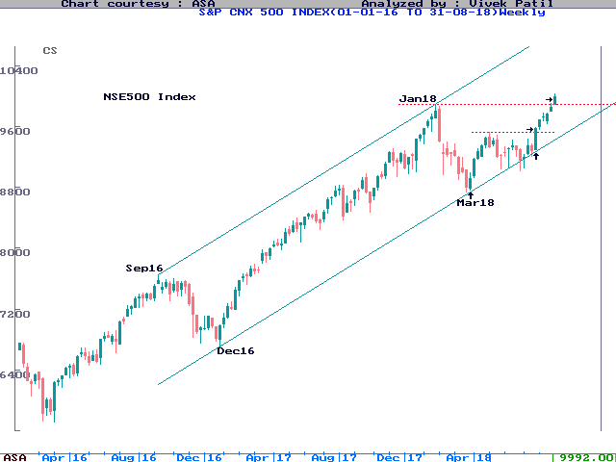
All the rising channels shown on various charts listed above enclose “higher top higher bottom” formation of price, which defines an UP Trend as per the basic Dow Theory.
The up-trend would continue as long as the charts keep making higher top higher bottom, and the same could turn into sideways or DOWN Trend only when the charts stop doing that.

As we contended for NSE500 Index during Jun-Jul’18, a marginal break of the channel can be temporary, even a buying signal, unless the chart makes “lower top lower bottom” below the channel.
On Sensex, we observed that all the pauses during the up-trend since Jun’18 low have been restricted to just 2-3 days. We, therefore, always expected Index to bounce back after every 2-3 day pause.
Further, even if any “pause” converts into a “fall”, we would initially expect the fall to complete within 6 days. As we pointed out, none of the falls since Dec’16 ever extended beyond 6 days, and indeed, most of them finished exactly in 6 days.
Since Jun’18, inside the rally we marked as c-leg of larger “g”, Bulls have bought on every 2-3 day pause. Bulls have also been supporting the Index almost exactly at the gap-up areas. As can be counted on the 30-minute chart above, there were at least 9 such gap-up areas, which provided technical support.
Last week ended by Sensex forming 3 consecutive Bear candles from Wednesday to Friday. For the fresh week, once again, we could watch if the pause remains restricted to 2-3 days, or extends beyond it to convert the same into a “fall”.
To prevent conversion of the “pause” into a “fall”, an immediate support is required. It means, Index needs to recover from the very first day of the fresh week, by forming a Bull candle, preferably with a close above Friday’s high of 38838 (Nifty 11728).
Until the pause extends beyond 2-3 days, and until a fall stretches beyond 6 days, our selectively +ve approach may continue as before. Remember, against 1% gain on Sensex/Nifty last week, the BSE Small-Cap & Mid-Cap Indexes, both, gained 2% and outperformed.

In a non-secular market, being “selectively +ve” could be tricky. Generally speaking those stocks maintaining higher top higher bottom, rising channels, and those breaking from some base formation, would be preferred.
Failure to recover strongly on the first day of the week and hit fresh highs would continue the pause beyond 2-3 days, perhaps up to 6 days, to test lower Grey channels or last Monday’s gap-up area, both of which are at similar levels.
However, if the Index holds last Monday’s gap-up area or the Grey channel, the +ve options would still remain intact, only stand postponed.
_____________________________________________________________

We had listed initial maturity signs as (1) Index correcting for more than 2-3 days (2) turning the “pause” into a “fall” lasting for more than 6 days.
As we pointed out, since 19th Jun’18, none of the pauses ever extended beyond 2 Bear candles. Further, since Dec’16, none of the falls ever extended beyond 6 days.
The maturity signs are yet to appear. This only suggested that Bulls still remain in control, still buying after every 2-3 days of pause.
As per NEoWave, a “larger” fall, which retraces an upward segment of rally fully in “faster” time, is usually considered as maturity sign for any rally.
Such a move is a NEoWave way to confirm that a structure is one direction may be over, and another structure in an opposite direction may be opening. This is still awaited.

Structurally, remember, we considered the up-move from the higher bottom of 4th Apr’18 as “g” leg of the larger Diametric from Dec’16. Inside “g”, we identified 3 lower-degree legs, like a Zigzag, till now.
We ended the lower-degree a-leg on 15th May’18. This was followed by the b-leg, which formed as a “Limiting Triangle” and ended on 4th Jul’18. The upward c-leg is still forming from 4th Jul’18 onwards.
The magnitude of c-leg is now very close to 100% ratio to a-leg, price-wise as well as time-wise. Their equality has resulted in c-leg touching the upper parallel line to the 0-b line.
Since a=c is typical ratio for a Normal Zigzag, the question is whether c-leg would now end near equality. As marked on the chart, c-leg is also touching 125% ratio with the largest leg of the “Limiting Triangle” in b-leg, “externally”, i.e. a ratio projected from the top of the Triangle.
Against 3021 pts achieved by a-leg in 28 days, the c-leg magnitude is 2766 pts in 26 days. If the c-leg is set to mature at upper end of the channel, we may look for maturity signs, if any.
To confirm that “g” leg completed as a Zigzag, NEoWave requires break below the 0-b line (1st stage of confirmation) and complete retracement of the c-leg (2nd & final stage of confirmation), both to achieved in the less than 26 days, i.e. in time lesser than the time consumed by c-leg.
As per the “Touch-Point Rule” of NEoWave, if the c-leg ends of a-b-c pattern ends at upper parallel line to the 0-b line, then the next move could be an “x-leg”.
Until the -ve parameters, as describe above, actually unfold, the Bulls could remain in control.
In case Index sustains decisively above the 125%-mark, then “g” could continue to develop further as a “7-legged” Diametric, or as a Complex Corrective.

As can be seen on the following chart, the BSE Small-Cap Index attempted to bounce from the lower end of its 2-year long support line :
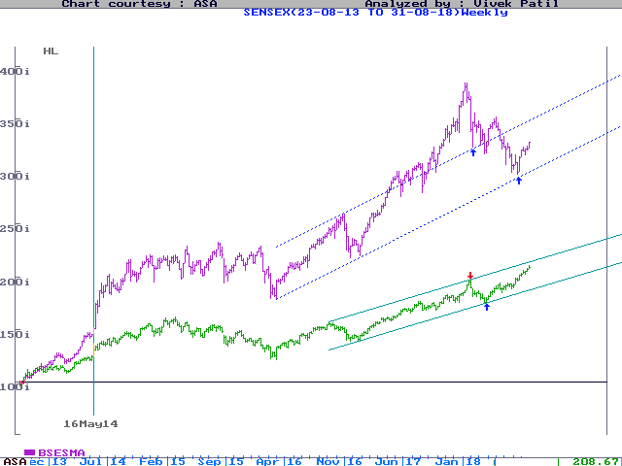
We chose BSE/NSE500 Indexes of top 500 stocks as a better Index for the investors. This was because Sensex & Small-Cap Indexes were moving in different directions. While one was hitting new all-time highs & the other was seen making fresh ‘2018 low till the preceding week.
If Sensex is likened to Dow, both based on 30 stocks, then BSE/NSE500 could be likened to S&P500, all of which are based on top 500 stocks.
As can be seen on the following chart showing VP’s Grid levels, Sensex is now breaking above the Grid level at 37400.

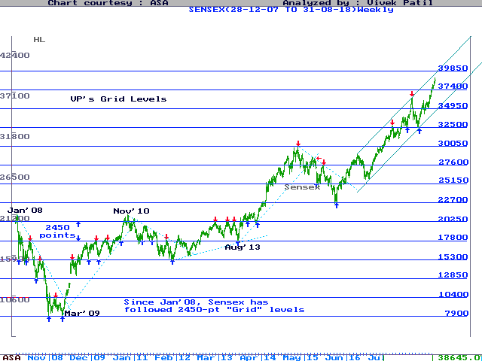
The 30-minute chart shows a-c and b-d lines enclosing the Triangle and Apex Point of the Triangle, the meeting point of a-c & b-d lines, which occurred at 30% time-ratio to the time consumed by the Triangle.
As per NEoWave, when the Apex Point lies within 20% to 40% time (as compared to the time consumed by the Triangle), then such a Triangle is considered a “Limiting” Triangle. As the name suggests, “Limiting Triangle” puts 75% (minimum) to 100% (maximum) as limits on the thrust.
These ratios are based on the “largest leg” of the Triangle. In our case, the largest leg (a leg) was 1691-pt 6-day fall from 15th May to 23rd May. The 75% minimum thrust implication from the end-point of the Triangle at 35310 (Nifty 10678) of 4th Jul, calculated as 36567 (Nifty 11063).

As per NEoWave, there are 2 types of Triangles, “Limiting” and “Non-Limiting”, depending on whether or not the Apex Point lies with 20% to 40% time-frame. While “Limiting Triangle” can occur as b-wave or 4th wave, the “Non-Limiting” Triangle occurs as the last corrective of a Complex Corrective (which involves x-wave/s).
One more point : As per NEoWave, the b-d line of the Triangle should be clean, but in our case, it is seen violated marginally. Though this may lead to structural invalidity in Future, it did allow us to project a minimum 75% thrust ratio based on its largest leg, and the same stands achieved.
Remember, a Triangle contains a “violent” fall in a leg, but the remaining legs absorb the violence, deny any -ve follow-up below a leg. Once the Triangle is over, the breakout occurs in the direction “opposite” to the violent leg.
We turned +ve after Index lost 11%, against 12% loss we targeted from the Jan’18 top. While Index lost 11%, the broader BSE Mid-Cap and Small-Cap Indexes had lost 18 & 23%, respectively.
After having achieved our downside expectation, Index was also testing its Nov-Dec’17 lows as well as 200-day EMA, where we expected some value-buying to emerge (refer to the chart above).
The channel equates the current fall with ‘2016 fall, both measured about 11-12% in about 3 months.

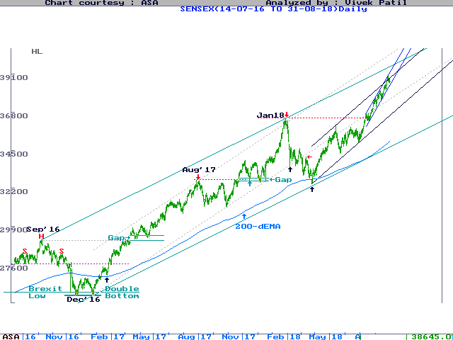
Dow also lost 12% from it top. The question is whether ‘Feb18 lows would be defended Globally.

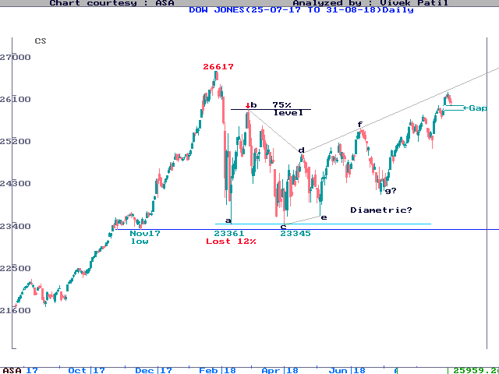
Remember, we had argued that as per VP’s 2-year Cycle of Tops, shown on the chart above, there are 3 categories of correction market experiences every 2 years (1) 12-13% (2) 2-30% (3) 50-60% (this generally happens every 8 years).
We considered the move from Dec’16 as a breakout from 21-month Neutral Triangle. The breakout, on one higher degree, was marked as “g” of the 3rd leg of a still larger Terminal from the year ‘2003.
In case the “alternate structure” confirms, the question would be whether it completes lower-degree a-leg of “g” OR an entire “g”. Anyway, this would be confirmed later, if at all.
As per VP’s trading rules, more than 5 consecutive Bull candle or 5 consecutive higher closes on Weekly chart is indicative of an “overstretched” rally.

Last year, possibly the fastest moving item in the World was Bitcoin, which gained over 1300% from $964 to $14156 in ‘2017. During the year, however, it shaved off 40% twice after if formed 5 consecutive Bull candles during Aug-Sep and Nov-Dec’17.
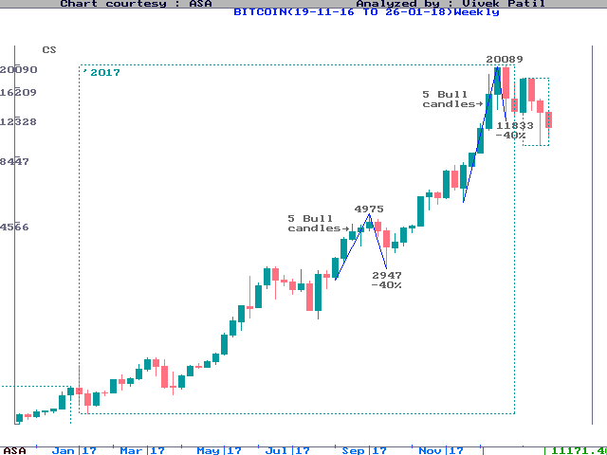
As can be seen on the following chart, most of the major tops were hit during the 1st quarter of a calendar year, right from ‘2000 onwards.

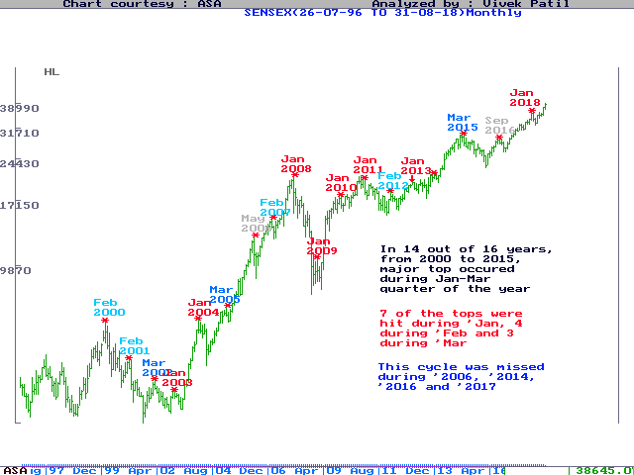
However, besides ‘2006 and ‘2014, this cycle was missed consecutively for the last 2 years, i.e. for ‘2016 and ‘2017. We are now already into the 1st quarter of ‘2018.
This cycle continued for many years mainly because of the influence of the Foreign Institutional Investors or FIIs, who were seen booking profits soon after a calendar year is over, which is the financial year for them.
However, during the last 2 years, domestic Financial Institutions or FIs appear to have increased influence on the markets, flush with SIP inflows.
The question is whether FIs would maintain control on the markets during ‘2018 as well, to cause another miss on the cycle discussed above.

The same point can be made about the 2-year cycle shown on the chart below, which shows market turning every alternate March, right from the year ‘1980 onwards.
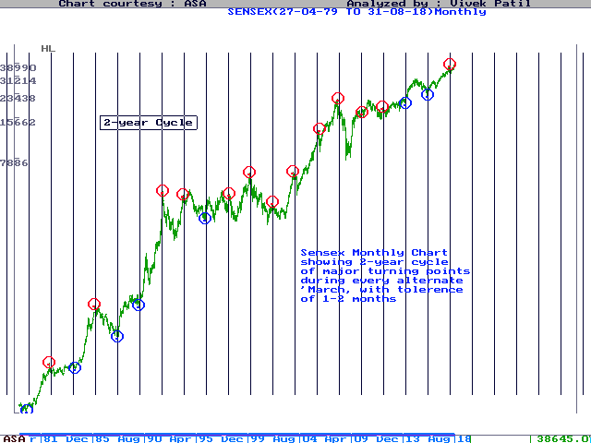
The last up-turn as per this cycle was seen near March’2016, and now we are within 1-2 months tolerance with the approaching 2-year cycle date during March’2018.
Despite the caution coming from the potential cycles discussed above, we continue to watch the Nifty PE Ratio chart given below. PE Ratio has an upside potential of 28-29, the levels last achieved during ‘2000 and ‘2008, which created euphoria before the collapse.
Maturity of PE Ratio would be signaled once it starts retracing its upward segment faster, eventually breaking the Green channel, and falling into lower top lower bottom pattern.

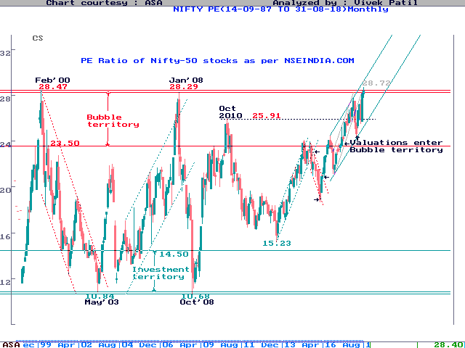
On Cycle-degree chart shown below, the breakout form the Neutral Triangle is considered as the “g” leg of the Diametric forming inside 3rd of the Terminal from ‘2003. The “g” leg can sub-divide.

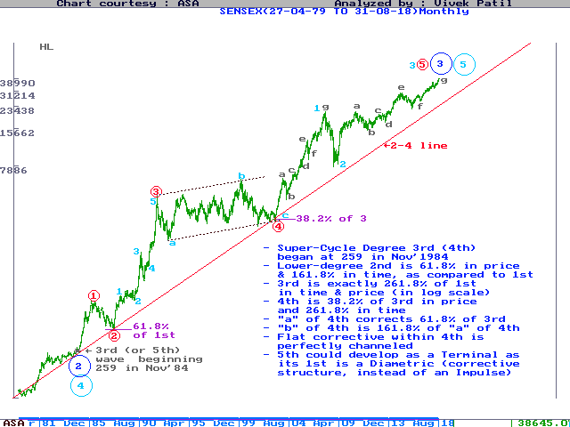
Initially, we are only expecting the minimum of these, i.e. 12% correction. Such a correction, remember, would also be similar to last year’s (‘2016) correction, as can be seen on the following chart.

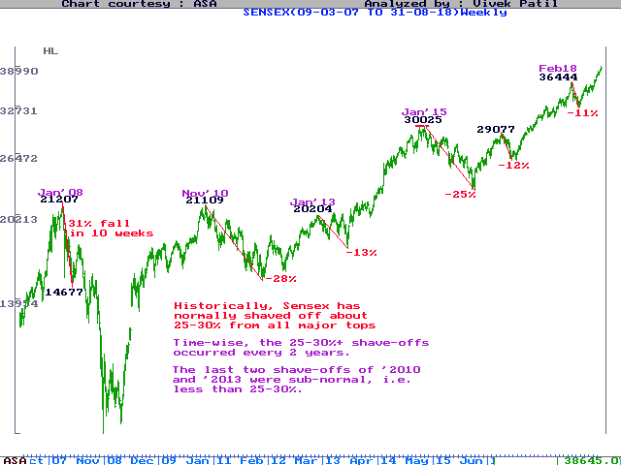
During ‘2016, Index corrected 3359 pts (Nifty 1075 pts) or 12% from 29077 (Nifty 8969) to 25718 (Nifty 7894), in 3 months from Sep to Dec.
We wonder if the Index shows a similar price/time correction to about 29000 (Nifty 9000). Note that testing 29000 (Nifty 9000) would also look like testing the ‘2016 top.
Starting from ‘1992, VP’s 2-year Cycle of Tops showed major reversals in ‘1992 (-57%), ‘1994 (-39%), ‘1996 (-34%), ‘1998 (-36%), ‘2000 (-58%), ‘2002 (-25%), ‘2004 (-33%), ‘2006 (-30%), ‘2008 (-64%), ‘2010 (-28%), ‘2013 (-14%), ‘2015 (-25%).
The chart does not show the reversal in ‘1992, but all of us know the “Harshad Mehta” top, when Sensex lost from a high of 4546 to the low of 1980. It also does not show the -41% reversal from the ‘1990 top.

As we showed on the chart above, all corrective phases in Indian market consumed about 13 or 21 months, both of which are Fibonacci Numbers. Dec’16 was the 21st month from Mar’15. Thus, the larger corrective phase may have ended as a Neutral Triangle in 21 months.
Neutral Triangle is a missing variation of Triangle under Orthodox Wave Theory.
Imagine, if Contracting Triangle is like 1st Extension Impulse, and Expanding Triangle is like 5th Extension Impulse, then Neutral Triangle would be likened to 3rd Extension Impulse.
Neutral Triangle, a discovery under NEoWave, is a 5-legged pattern, just like any other Triangle, but its c-leg is biggest (like 3rd Extension), and a-leg and e-leg tend towards equality.
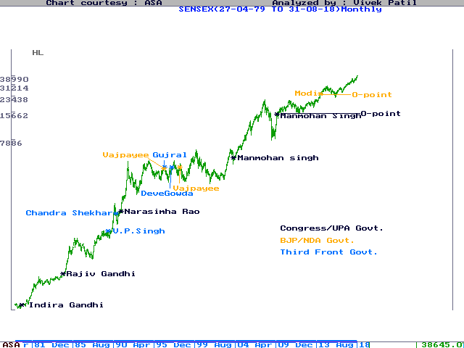
Over 3 years ago, we showed performance of Sensex post elections on the chart given above. As shown on the chart, Sensex’ performance always remained subdued after a non-Congress Govt gets elected.
Remember, Sensex was also testing the crucial Monthly Base line we showed on the following chart, and the same has been broken. Post-Feb’16 rally looks like a “pull-back” to the broken line.
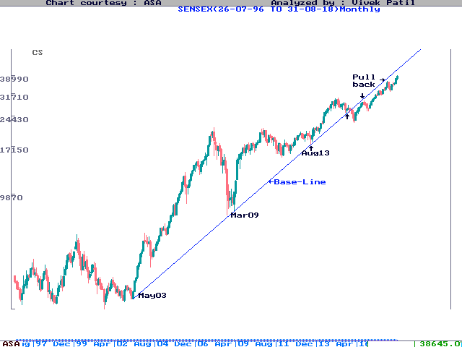
Last time FIIs sold out was during Oct’07 to Mar’09, when the Index shaved off as much as 63%. FIIs invested Rs.612000 crs after Mar’09, but Dollex-30 showed un-impressive gains during this period, as it is still below its ‘2008 highs.

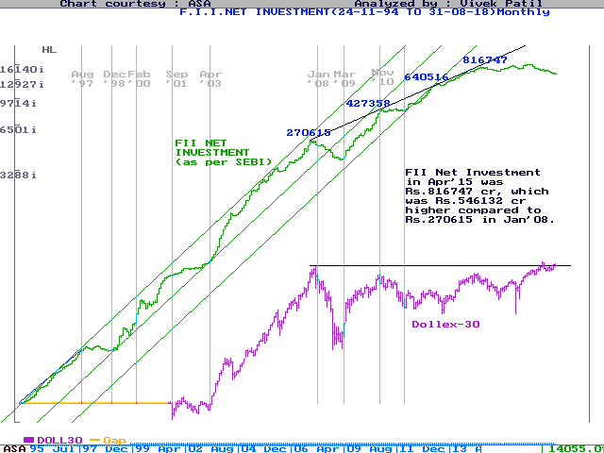

Technical readings carried forward from previous weeks
We alternatively considered post-Aug’13 development to be F leg of a larger Diametric formation from ‘2008 onwards as shown on the chart below :
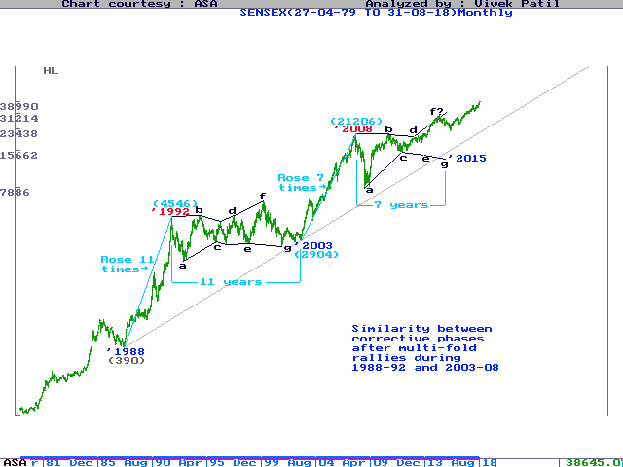
This long-term scenario marking the larger Diametric was published on 6th Feb’12. This Diametric assumption, as was argued, compared well with the 11-year Diametric formation previously seen during ‘1992 to ‘2003.
As shown on the chart above, F is the “Expanding” leg of the 7-legged Diametric from ‘2008. In the previous instance of the Diametric during ‘1992-’2003 period, F leg had hit new highs during ‘2000.

In other words, F leg of the diametric making new highs is nothing new. After hitting new highs during ‘2000, G leg went down till ‘2003.
We argued for a Diametric development from ‘2008 onwards because we observed time-similarity within most of its legs, which is symptomatic of such a pattern. So far, most of the legs, except B and D, have consumed exactly about 13 months.
On the monthly Close-only chart given below, one can see Sensex crossing previous highs, indeed taking their support for reaching further newer highs for the F leg :
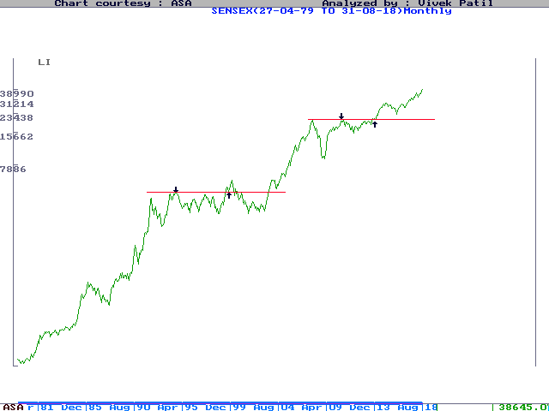
We considered this alternate scenario when Sensex moved above 2008-10 highs. It shows corrective phase from ‘2008 completing as a 5-legged Ascending Triangle. This scenario opened much higher targets, 30000+ for Sensex, and the same has been achieved.

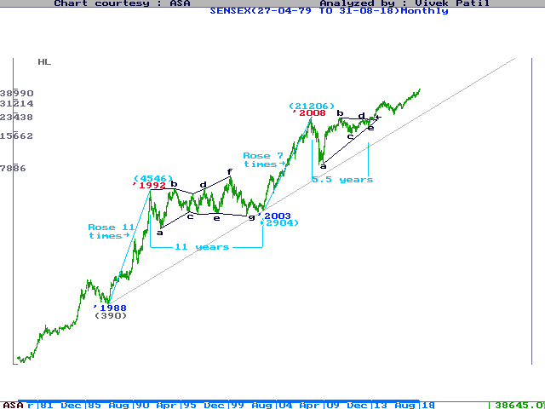
The 30000+ target was nothing but 100% (+/- 25%) breakout implication of the largest leg of the Triangle.
According to NEoWave, corrective phase should consume more time than the move it is correcting. After the 56-month rally from May‘2003 to Jan’2008, Sensex has corrected for 67 month from Jan’2008 to Aug-13, i.e. a larger period as required under NEoWave.
We cannot rule out that a sufficient time-correction is required after any multi-fold rally. As shown below, such time correction can last for as much as 161.8% to 261.8% time ratio to the multi-fold rally.
As for the last multi-fold rally during ‘1988 to ‘1992, its correction had lasted for 262.8% time ratio, from ‘1992 to ‘2003.

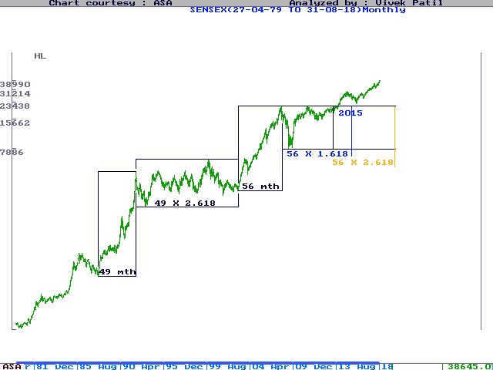
We argued in favor of long term consolidation phase beginning ‘2008 because prior to ‘2008, Sensex had multiplied 7 times from its ‘2003 lows. We argued, such multi-fold rally could results into a multi-year consolidation phase. Inside such a phase, even moves reaching new highs are considered its internal part, and not as breakouts.
As we noted, after 11-fold rally during ‘1988 to ‘1992, Sensex consolidated for 11 years till ‘2003 (261.8% time ratio). Within this consolidation, Sensex corrected as much as 30-60% every time it came closer to previous highs or even after hitting new highs.
An ideal “suckers rally” usually involves making a New High. As we can be seen on the chart below, Sensex moved higher than its ‘1992 highs during ‘1994 and ‘1997, but reacted by over 30% both the times.

Later during ‘2000, it broke 1992/1994/1997 highs, by as much as 1500-1600, only to lose 58% later. After a severe corrective phase lasting from ‘2000 to ‘2003, Index broke ‘2000 high during ‘2004 by 100 pts, but even then shaved off 30% before the next rally could take place.
All this happened because the 11-year long ‘1992-2003 phase was a multi-year corrective phase correcting the preceding 11-fold rally from ‘1988 to ‘1992.
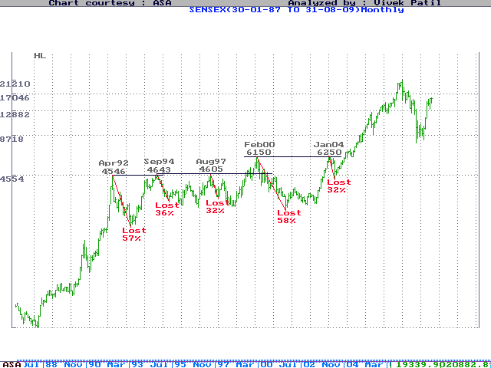
On the super-cycle degree, we are considering a “Terminal” development since ‘2003 onwards. The Terminal was suspected because its 1st wave from 2003-2008 was a label-3 “corrective” pattern. (As against a normal label-5 Impulse pattern).
The 2003-2008 rally was internally marked as a corrective pattern called a Running Diametric.

We could be forced to consider up-move since ‘2009 as the 3rd of the Terminal Impulse, as per the Blue labels shown above.
The basic NEoWave requirement is that a corrective phase should consume more time than the move it is correcting. The ‘1992-2003 corrective phase, remember, continued for a time-ratio of 261.8% to the preceding 4-year rally from ‘1988 to ‘1992.
As per Wave Theory, a corrective phase shapes up as 3-legged Flat/Zigzag, 5-legged Triangle or 7-legged Diametric (which basically combines 2 Triangles).

Comparable Multi-year long Diametric formation on Dow
It was argued for a long time that all multi-fold rallies would be followed by multi-year long consolidations. Sensex, remember, rose 11-fold during ‘1988 to ‘1992, but entered a 11-year consolidation thereafter.
Again, during ‘2003 to ‘2008 it multiplied 7 times. Drawing similarity, it could see a minimum 7-year consolidation starting ‘2008. Further, the consolidation, may shape up like a 7-legged Diametric, similar to the consolidation seen from ‘1992 to ‘2003.
The Diametric formation from ‘2008 is also suspected because each of its internal legs, except B, have consumed about 13 months so far.

Long-term corrective phase on Dow’s chart also appears to be a probable 7-legged Diametric. Instead of “Bow-Tie Diametric” on Sensex, Dow’s Diametric is shaping up as “Diamond-Shaped Diametric”.
The chart of Dow also shows similarity with its earlier long-term phase between ‘1966 and ‘1982, which also shaped up like a “Diamond-Shaped Diametric”.
The D-leg on Dow has now hit a New High, just like it did in the previous phase. The D-leg could now form some topping formation over the next few months.
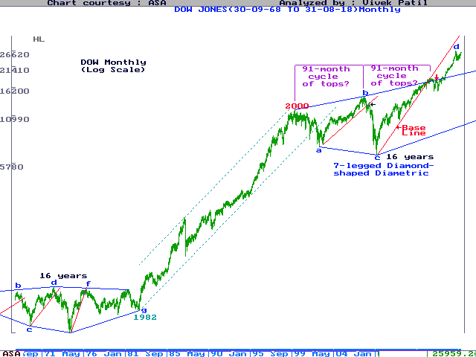

BSE Dollex-30 Index
Meanwhile, since the FII activity turned a prominent factor in the Indian stock market, we examined the development of BSE Dollex-30 Index.
This Index shows Dollar-Value of Sensex, and it has hit a fresh record high compared to its last high made during ‘2008.
It is now seen breaking the Green support line show, but is now seen re-attempting its ‘2008 highs.
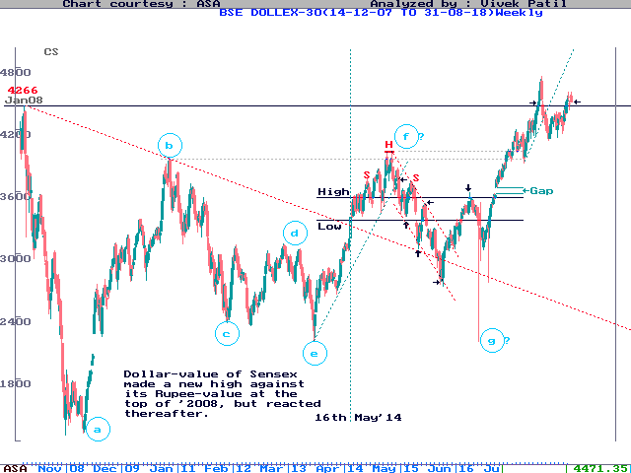

BSE Small-Cap Index
The Small-cap Index on its Weekly chart is seen crossing the Red line drawn from Jan’2008, and testing upper end of the Grey channel.
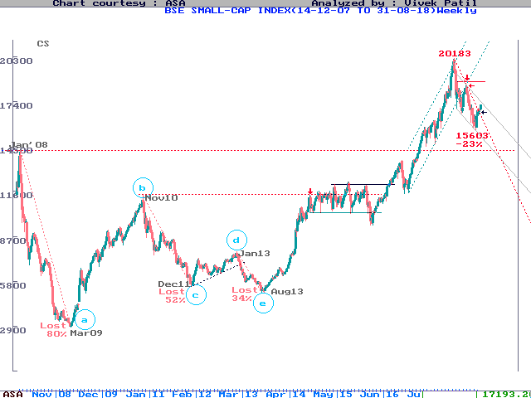

BSE-500 Index
After BSE-500 Index reached new high levels, it hesitated at upper end of the Green channel shown, and is now recovering from its lower end.
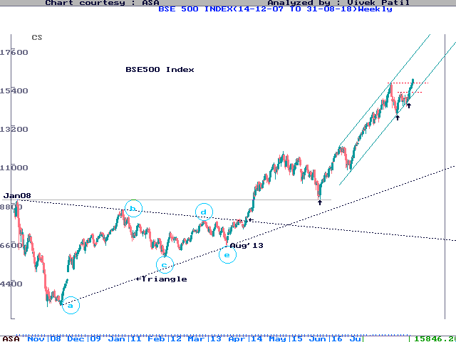

OBV
On Balance Volume (OBV) adds up or accumulates each day’s volumes as positive or negative, depending on day’s close.
The Red line stands broken. Now watch the Black Line.
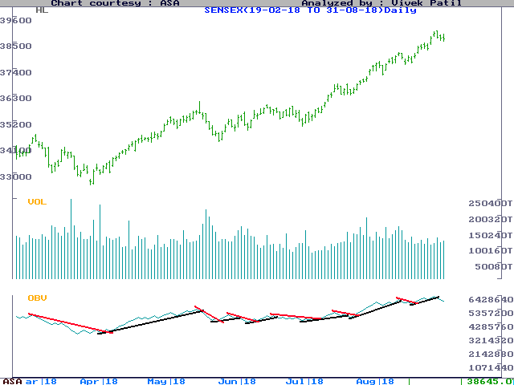

Daily MACD/KST
While Moving Average Convergence Divergence (MACD) is based on difference in two different Moving Averages, the Know Sure Thing (or KST) is based on various smoothened ROC (Rate of Change) values. Both of these are known to be “smoothened” technical indicators.
The Red line is now broken. Now watch the Black line.
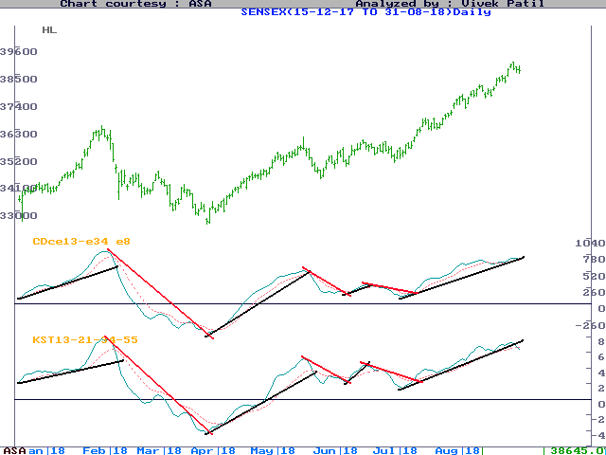

Weekly MACD / KST
Weekly charts of MACD and KST held around the 0-levels. Both the oscillators have now broken above the Red line we showed.
We were watching the Red line as crucial, which now stands broken. Now watch the Black line.
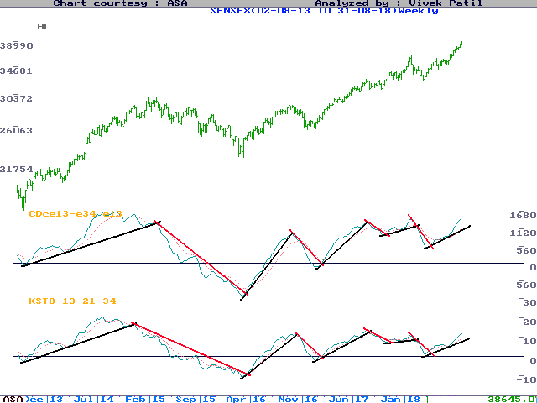

Nifty PE Ratio
The following chart shows PE Ratio plotted for Nifty-50 stocks, as taken from data published on NSE’s website. While 28 appears to be the highest PE Ratio during the last two 8-year cycle tops of ‘2000 and ‘2008, 22-23 appears to be the highest level otherwise under normal conditions. The lowest levels of PE Ratio are close to 11.
In ‘2010, PE Ratio was testing what was called a “Bubble” territory. Long term investors may keep a tab on the PE Ratio as and when is enters the “Investor Territory” shown on the chart.
The PE Ratio was into the Bubble Territory, maintaining the Grey rising channel.

Sensex PE Ratio
Given below is the chart of Sensex PE Ratio, covering a longer history, since ‘1991. This chart showed the highest levels of 55-56 during ‘1992 peak. However, on 10th Jun 95, Economic Times reported that BSE’s PE Ratio calculations were based on out-dated data, which led to a wrong PE multiple till then. BSE, then, revised the PE overnight on 14th Jun’95, from 29.44 to 18.51. This appeared horrifying to those who realized that official data can be totally misleading. After adjusting the data (a technical adjustment like bonus shares), the chart shows the highest levels of about 34.
All of us make our judgments based on official data like IIP numbers, GDP figures, Inflation, Fiscal deficit, etc. We’d do well to consider most of these data figures after due diligence.
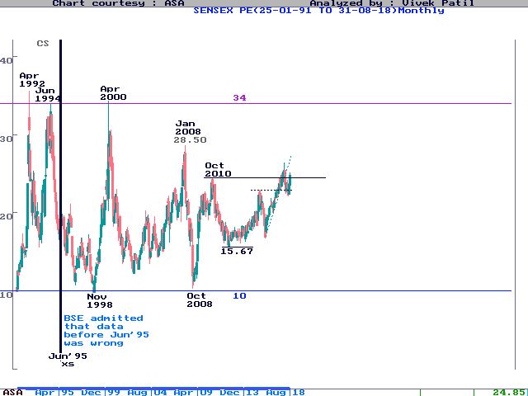

The 8-Year Cycle
The Sensex is also assumed to be under the influence of a large 8-year cycle ever since its birth. As shown on the chart below, '1984 was the beginning of 8-year long bull-run till '1992. In our Super-Cycle Degree count, shown on ASA Long-Term chart under a separate paragraph, we’ve considered ‘1984 as the beginning point for the most dynamic 3rd wave.
The next two important turning points occurred exactly 8 years thereafter, in '1992 and '2000. Both these turning points were marked by stock market scams, because of which, the leaders of the rally had extremely difficult time later. For example, ACC, the leading stock of '1992 bull market, remained below its highs till end of '2004. Similarly, the IT stocks, which were leaders of '2000 rally, lost as much as 90% of their top valuations by the year '2003.
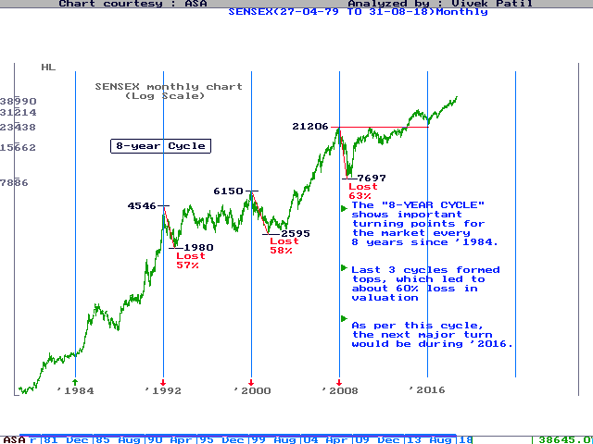
In the previous 8-year cycle top during ‘1992, Sensex lost 57% from 4546 to 1980. In the next cycle top, the cut was almost 58% from 6150 in ‘2000 to 2594 in ‘2001.
We had, accordingly, targeted sub-10k levels for Sensex price-wise during ‘2008-09, and a minimum of 13 months into bear phase, time-wise. The price-time targets were achieved as Sensex dropped 63% from 21206 to 7697. The yearly channel, shown below, which was used earlier to project 20000 level for the Sensex during ‘2007, was broken when the Index moved below 17200. Break of this long-term channel also weighed in favor of a larger corrective phase following this 8-year cycle.
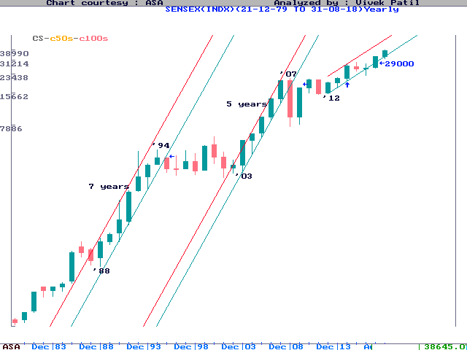

Domestic Institutional Investments
The Net Investment figures for Indian Mutual Funds, as available from SEBI website, showed positive structure till Aug’09. Mutual Funds are usually late sellers in the market. Last time, while Sensex topped in Feb’00, their sell-off began during ‘2001, and lasted for 3 long years.
(As the chart went into -ve, a base figure of 100000 crs. is now added)
This non-traded chart also throws interesting wave-structure, as marked. Based on this, it was argued that “5th of the 5th should not cross 156018.” Chart did react lower without crossing 156018, and indeed saw its biggest sell-off due to heavy redemptions from domestic investors.
Since May’2014, heavy inflows from domestic investors, either through SIP or otherwise, have seen a big rally on the chart.
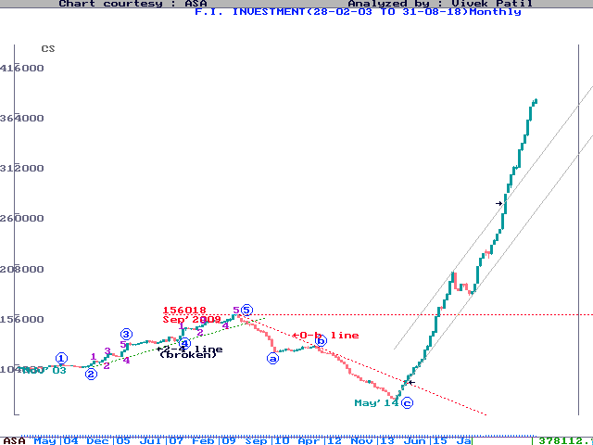

Dollar-Rupee
The wave structure for Dollar-Rupee chart is shown below. The chart has held the 61.8% retracement levels to the last rally marked as 3rd.

Recent action shows it touching a new high of 71.42, against its previous high of 69.23.

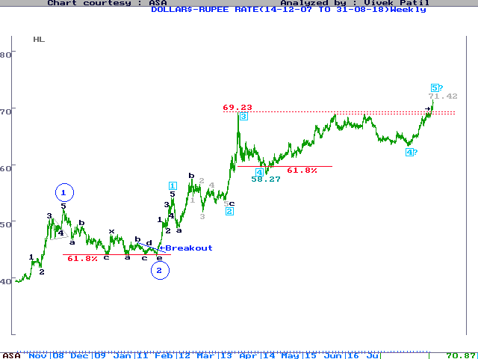

Dollar Index
We had noted the structure of Dollar Index chart showed potential bottom getting formed on the chart.
The chart showed a triangular base, which now appears breaking on the upside. We were watching the Blue resistance line joining its previous two tops, which was broken above recently.
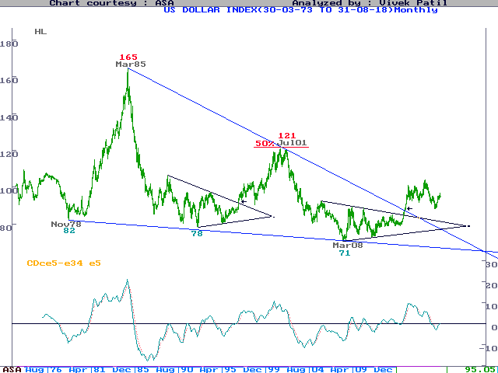

DOW
Dow’s probable wave-structure is shown on the chart below :
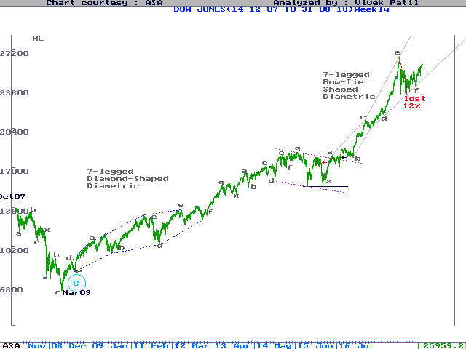
On one higher degree, Dow appears to be inside a long-term corrective phase, just like Sensex. Its wave structure for the long-term corrective phase, draws similarity with the long-term corrective phase from ‘1966 to ‘1982, as can be seen on the chart below :

Dow has broken the crucial base lines on Weekly as well as Monthly charts marginally, and is now recovering inside the Grey channel, as can be seen above.

ASA World Index
On the Monthly chart of ASA World Index (which is based on all active stock market indices around the World), Technical Channels are as shown below :

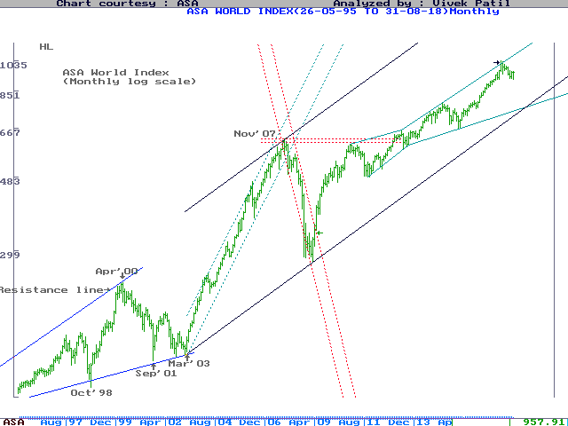

Comparison between Developed and Emerging markets
Following chart compares stock indices of Developed and Emerging economies. Since ‘2009,

Emerging markets have outperformed the Developed economies.

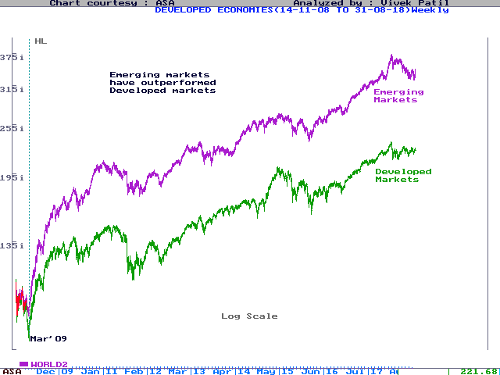

MCX Crude
For Crude, the probable wave-structure is presented below :
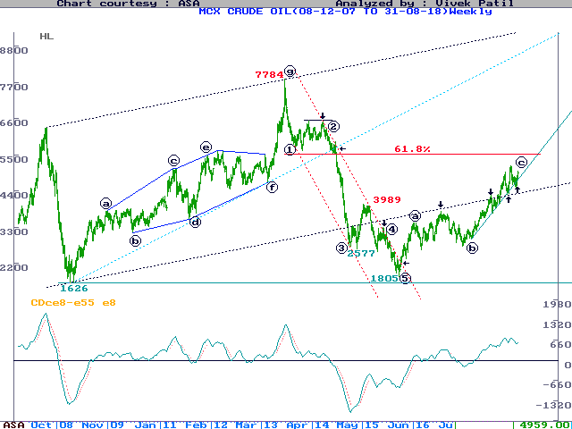
Crude reacted from pull-back level to the larger Black channel, but has now recovered back into the same. Watch the Green line as crucial on downside.

MCX Gold
The probable wave-structure for MCX Gold has been presented below. After hitting a Double Top during late ‘2012, gold broke the 2-4 line, indicating the Impulse of one higher degree is over.
The drop from Dec’12 was shown as probable 4th of one higher degree, which was projected to drop to around 25000 levels. Very close to the projected level, some support was expected.
Overall, however, 4th could continue to develop for a period of more than 5 years from ‘2012 onwards, consuming more time period compared to 3rd.
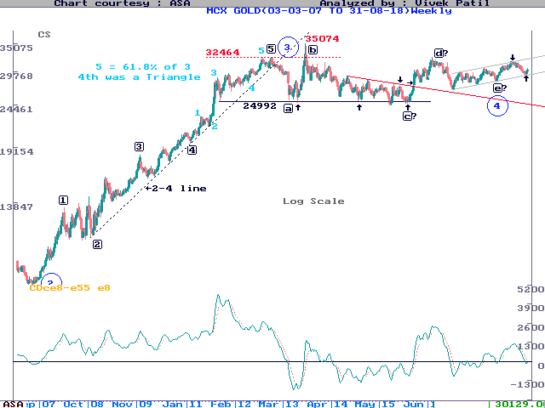
Gold is now approaching lower end of the Green channel, where some support cannot be rule out.

MCX Silver
Silver was resisted at its last high marked in Red, and is currently testing its last low marked in Green.
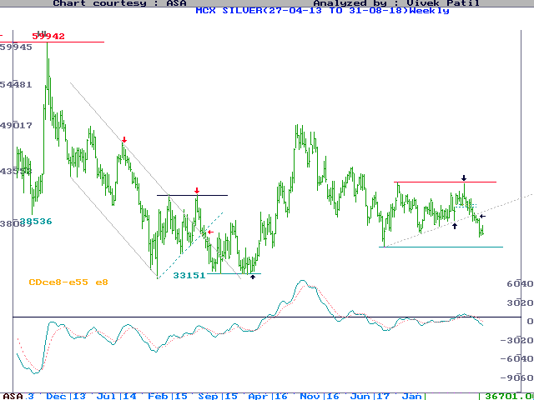

Appendix : Super-Cycle Degree Wave-scenario for Sensex

For Super-Cycle-Degree wave-scenario, consider following ASA Long-Term Index. This Index has been created by combining a very old Index compiled by a British advisor (from '1938 to '1945), with RBI Index ('1945 to '1969), F.E Index ('1969 to '1980) and Sensex (thereafter till date).

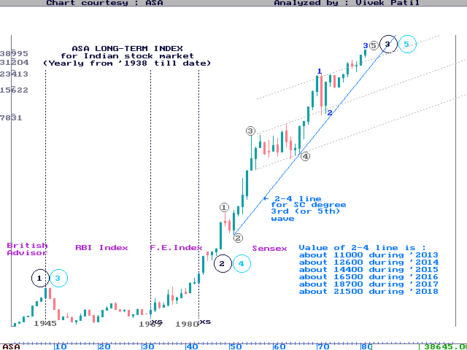

The wave-count presented shows that the market is into the lower-degree 5th of the SC-degree 3rd or 5th wave.
The detailed wave-count from ‘1984 onwards can be seen on the Monthly chart given below. The 2-4 line shown on the ASA long-term Chart above, and Monthly chart below, would determine if the post ‘1984 Impulse is a Super-cycle-degree 3rd or 5th.

Super-Cycle-Degree 3rd (or 5th) began since Nov’84. Its internal 3rd was an “extended” leg, which achieved exactly 261.8% ratio to the 1st on log scale. The Sensex is now forming the 5th Wave, and the same could develop as a ”Terminal”, because its lower-degree 1st wave from May’03 onwards developed as a Diametric (which is a “corrective” structure, rather than an “impulse”). Within the non-directional legs, 2nd was exactly 61.8% of 1st value-wise, and 161.8% time-wise. The 4th was 38.2% of 3rd value-wise, and 261.8% time-wise.

While the 4th is shown as a 3-legged a-b-c Flat on the monthly chart above. Alternatively, the 4th is shown as a 7-legged a-b-c-d-e-f-g Bow-Tie Diametric on the Monthly chart below. The chart below also shows 11-year parallel channel from Apr'1992 to May'2003. As shown, if one projects the width of this channel on upper side, such a projection gave 20000 as the “minimum” target. This forecast was achieved.

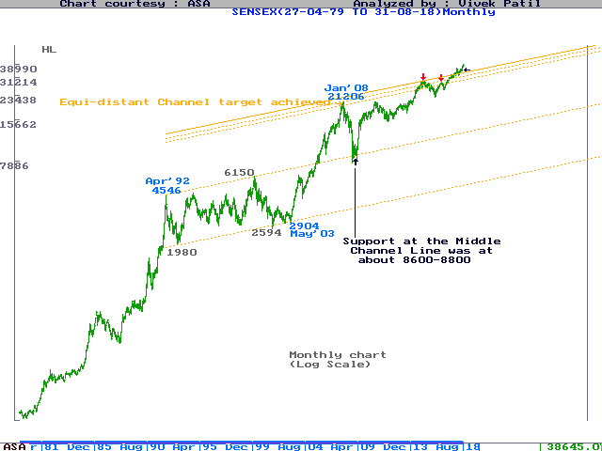

As mentioned above, the lower-degree 1st from May’2003 to Jan’2008 appears to be a Bow-Tie Diametric, marked as a-b-c-d-e-f-g. It is called "Diametric" because it combines two Triangular patterns, one initially “Contracting” up to the "d" leg, followed by an “Expanding” one. The contraction point is the "d" leg, and the legs on either sides of it tend to be equal. Accordingly, "c" and "e" were equal in "log scale", both showing about 60% gains. Similarly, "g" was equal to "a", both showing about 115% gain.

The Diametric development from ‘2003 to ‘2008 is considered to be the 1st wave of the Impuse. Due to the corrective structure in the 1st leg, the higher-degree 5th could be developing as a Terminal. Since ‘2008, we are into its 2nd wave, which could continue to develop over a period of 7-8 years beginning ‘2008.

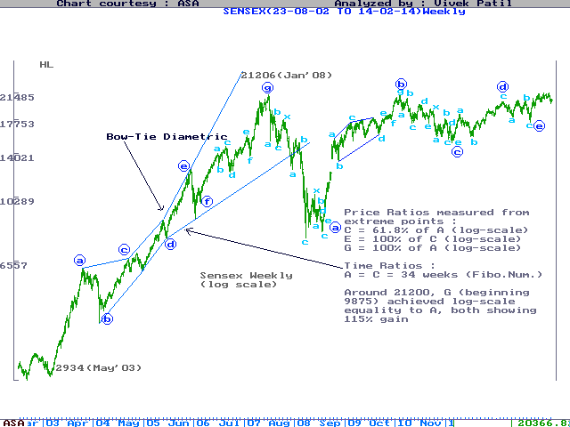

As per NEoWave, break of 2-4 line confirms a Terminal development, and If the 5th proves to be a Terminal, the Super-Cycle-degree label of 3rd will have to change to 5th, because only a 5th of a 3rd cannot be a Terminal. Only a 5th of the 5th can be a Terminal. The Super-Cycle-Degree marking for 1st and 2nd as shown on ASA long-term chart, would then change to 3rd and 4th respectively, as shown in Blue.

Disclaimer : While due care has been taken in preparing the above Analysis, no responsibility can be or is assumed for any consequences resulting out of acting on it.

