Vivek Patil’s

Daily Stock Analysis
14-Aug-2018
HCL Tech [`983.00] : Holding above Rounding Bottom
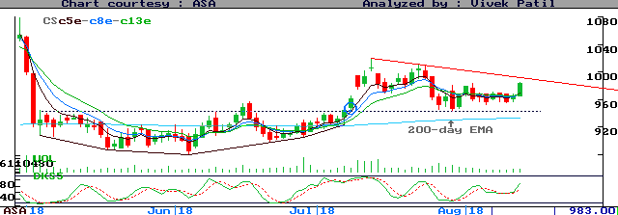
HCLT appears holding above the Rounding Bottom and 200-day EMA. We may buy whenever it strengthens above its opening levels or 984.25, expecting 989 / 1040 or higher levels. SL - close below 981.

TCS [`2000.15] : Watch if range breaks upside
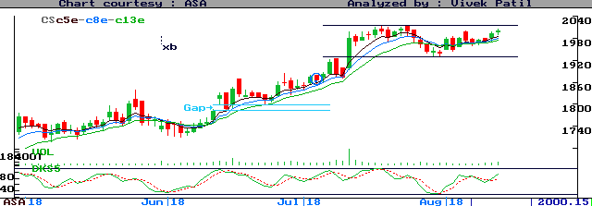
TCS is trading in a flat range, and is on the verge of testing its upper end. We may buy whenever it strengthens above its opening levels or 2003, expecting 2008 / 2090 or higher levels. SL - close below 1998.

- Always maintain a stop-loss. To preserve your profits, put trailing stop, to be adjusted as the price moves in your favor.
- First target (T) is generally for traders. Investors are advised not to reverse positions until at least first TG is met or stop-loss (SL) is hit. Smart Investors my continue to hold the position even beyond 2nd target, but with stricter stop-loss levels.
- Intra-day Traders should shift SL just beyond the opening 20-minute trading range for the stock. Traders may or may not continue to hold positions for targets, and may scalp profits as and when seen sufficient.
- Price movement may not usually be a unidirectional affair. This suggests a two-way approach required intra-day. Traders are advised to follow trend-line/channel breaks, oversold/overbought oscillator positions in order to refine their entry/exit points and stop-loss levels.
- Be careful if a counter achieves targets immediately after opening. Wait for reactions.
- Unless specified otherwise, charts show latest 45 daily candlesticks on NSE cash market, with 5/8/13/200 day Exponential Moving Averages, volume and 5-day Slow Stochastic oscillator.
- The writer may have position in the stocks discussed.

Disclaimer
While all due care has been taken in preparing the above Strategies, no responsibility can be or is assumed for any adverse consequence resulting out of acting on them.

