Vivek Patil’s
Daily Market
Analysis
03-Sep-2018

Would pause on Sensex end with 3 Bear candles again ?

+ve if Sensex closes above Open & Friday’s high, else …

Last Close : Sensex 38645 (Nifty Spot 11681)
Today’s Trade
Positive if Sensex holds above 38645 (Nifty 11681)
[Upside targets/resistances at 38732(11694)/38838(11727) or higher]
Negative if Sensex keeps below 38838 (Nifty 11727)
[Downside targets/supports at 38732(11694)/38645(11681) or lower]

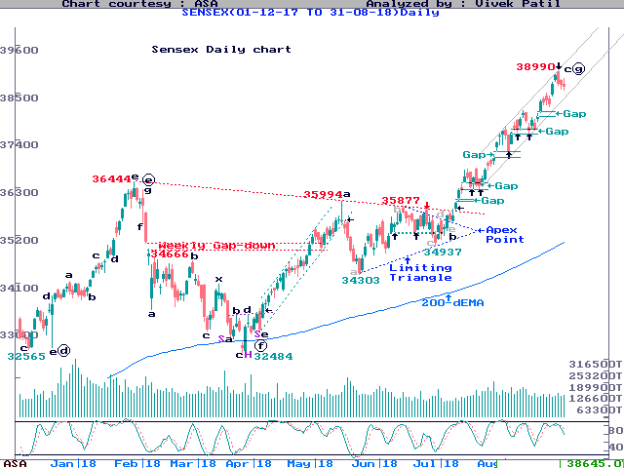
Review
As we discussed, “Nifty formed a Hammer-like candle, which can be +ve on strength/close above its Head … broader Indexes managed Bull candles, suggesting things were not so bad in the broader market … mainline Indexes were perhaps weighed down by the Expiry considerations … Rally can resume if pause remains restricted to just 2-3 days. We already saw 2 Bear candles. So, going by the existing pattern, Index could recover today or Monday … +ve options can open today if action generates follow-up above late high, or on Monday if it strengthens/ends above Today’s high … ”
Sensex opened flat, but strengthening above Open, it went 182 pts higher by by 10 am. However, unable to sustain above previous day, it lost 276 pts by 1 pm, before finally settling 45 pts or 0.1% lower for the day. The pressure came mainly from Reliance which lost 2.5%. The Pharma/IT/Power Indexes gained 1-2% each, and the A/D Ratio settled marginally +ve.
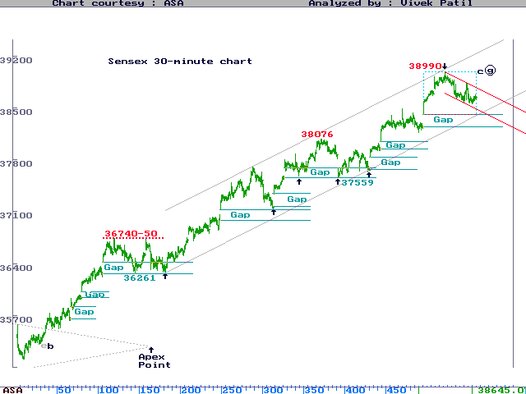
Analysis and Trading Strategy for the day
The action formed the 3rd consecutive Bear candle on Sensex. It made a higher high as well as lower low, suggesting Index could not close beyond previous day’s range, after breaking the same on both sides.
It also meant a volatile trade on 1st day of the new account. While the net close was almost flat, the up-down legs, intra-day, totaled up to a hefty 575 pts (over 200 pts on Nifty). As mentioned, trouble came from Reliance.
The broader BSE Small-Cap & Mid-Cap Indexes, both, formed Bull candles, 2nd on Small-Cap and 3rd on Mid-Cap. The BSE500/NSE500 Indexes also formed Bull candles, and even hit their new all-time highs.
Nifty formed a High Wave, a Bull candle with “higher” high-low compared to previous day, though it could not close above previous day’s hammer, mainly due to pressure from the heavyweights Reliance & Yes Bank.
As for Sensex, it paused for 3 days after hitting upper end of the Grey channels we showed on Daily as well as 30-minute charts. We are now watching if the “pause” remains a “pause” and does not convert into a “fall”.
We, remember, contended that the rally would remain intact if the pause remains restricted to just 2-3 days at a time. We also argued if the pause does remain so restricted, Index could recover from Monday, i.e. today.
Accordingly, consider +ve options if today’s action sustains above Open, and later also closes above Friday’s high of 38838 (Nifty 11728). In such a case, our selectively +ve approach should continue in the broader market.
Failure to open +ve options, as described above, would continue the pause beyond 2-3 days, perhaps up to 6 days, to test lower Grey channels or last Monday’s gap-up area, both of which are at similar levels and crucial.

Disclaimer
While due care has been taken in preparing the above Analysis, no resonsibility can be or is assumed for any consequences resulting out of acting on it.

