Vivek Patil’s
Daily Analysis of Derivative Market
14-Aug-2018
Nifty ‘Aug Fut. (11381) : H&S projection achieved
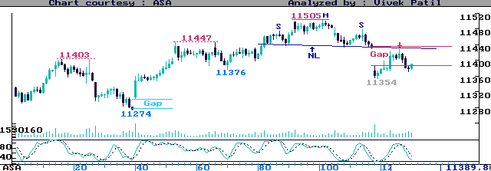
(Half-Hourly Chart - Aug’18)
Today’s Trade : Height of H&S (70 pts), projected from NL, is achieved. Trade -ve if keeps below 11425, weakens below Open - TG 11385-95 or 11360-70 initially - SL above 11435. Else, trade +ve if holds near 11385-95 or 11360-70 - TG Opening Highs or 11385-95 initially - SL below 11350.

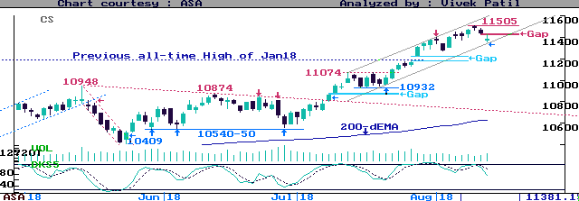
(Daily Chart - Aug’18)
Analysis & c/f : We carried shorts below 11425. Put SL above 11435. Can pause limit to 2-3 days ? Now at lower Grey channel, book shorts if 11354-72 holds & NF sustains above Open. Re-short if fails to reach/sustain 11430-35. Carry longs if closes above 11435 or shorts if closes below 11350.

(1) SL = Stop-loss (2) TG = Target (3) NF = Nifty Future (4) Opening Highs/Lows = High/Low made during first 5 to 20 minutes of trade (ignoring erroneous/misleading opening quotes resulting out of opening order load) C/F = Carry Forward.

- Always maintain stop-loss. To preserve profits, put trailing stops, to be adjusted as the price moves in your favor.
- Positional traders are advised not to reverse positions until target is met or SL is triggered. Smart traders may continue to hold the position even beyond targets, but with stricter stop-loss levels.
- Intra-day Traders should shift stop-loss just beyond the opening high/low. Traders may or may not continue to hold positions for targets, and may scalp profits as and when seen sufficient.
- Price movement is usually not a unidirectional affair intra-day. This suggests a two-way approach required intra-day. Traders are advised to follow trend-line/channel breaks, oversold/overbought oscillator positions in order to refine their entry/exit points and stop-loss levels.
- Be careful if a counter achieves targets immediately after opening.
- Unless otherwise specified, all Buy/Sell/SL/TG action levels are in terms of current month’s Future.
- The writer may have position in the counter discussed.

Disclaimer
While all due care has been taken in preparing the above Strategies, no responsibility can be or is assumed for any adverse consequence resulting out of acting on them.

